**PRACTICAL 05**

**Q1.** Write a Shell script to accept a string as command line argument and reverse the same.

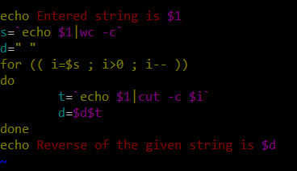

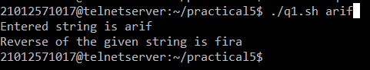

**Q2.** Write a shell script to calculate the loss percentage of an article, given the cost price and the selling price as command line arguments.

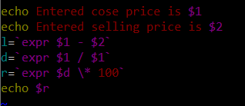

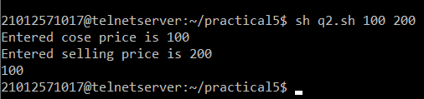

**Q3.** Write a shell script to accept the name of the user and check out if the same has logged in or not.

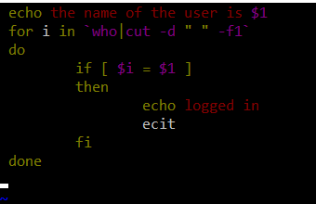

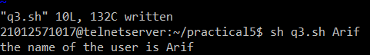

**Q4.** Write a shell script to check whether the file whose name is scanned exists and readable.

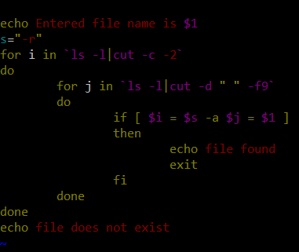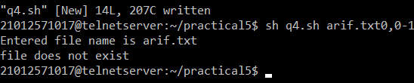

**Q5.** Write a shell script to check if the input string is a palindrome.

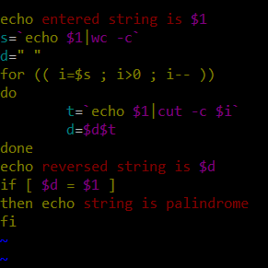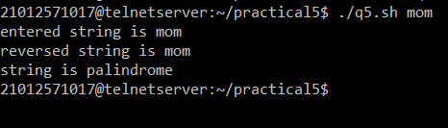

**Q6.** Write a shell script to accept a number and a word as command line arguments and print the word the given number of times on each line.

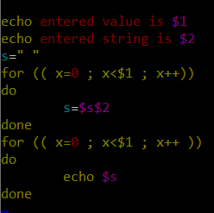

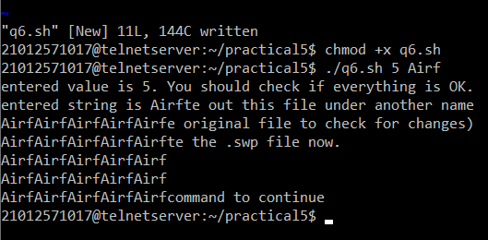

**Q7.** Write a shell script to find the file or directory with the maximum size in the current directory.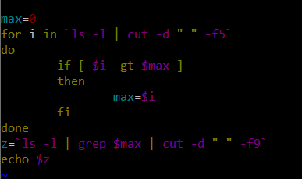

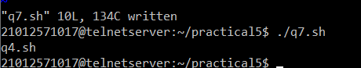

**Q8.**Write a shell script to accept two filenames and check if both exist. If the second filename exists, then the contents of the first filename should be appended to it. If the second filename does not exist then create a newfile with the contents of the first file.

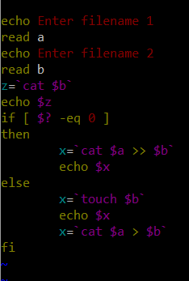

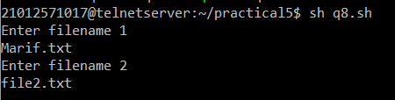

**Q9.** Write a shell script to accept a number in the command line and displays the sum up to that number. By default, the sum up to 50 should be displayed.

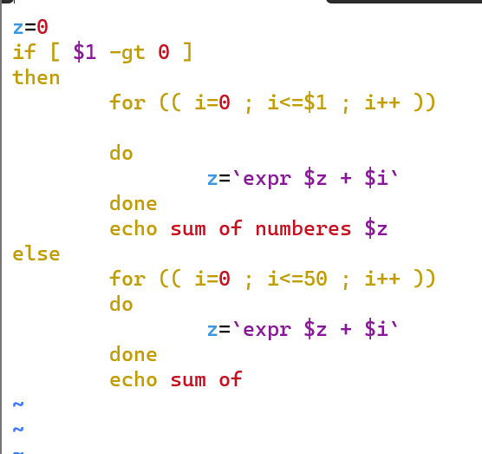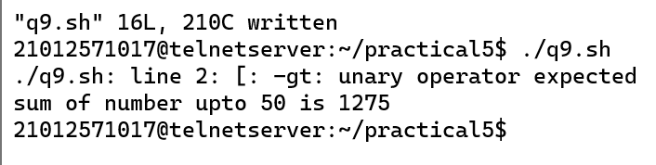

**Q11.** Write a shell script to accept an alphabet from the user and list all the files/directory starting with that alphabet in the current directory

